Change the Instance type of an EC2 Instance

Pre-requisites:

* AWS Account
* Editor to edit python script if needed
* Policy and role to be created – I have specified the details in the Steps

Steps:

* Login to AWS account
* Navigate to AWS Lambda Service

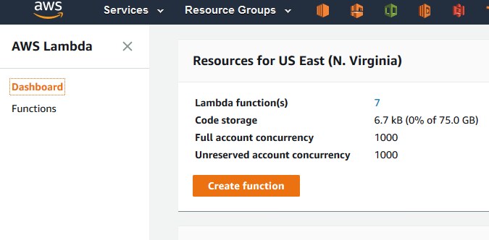

Click “Create function”

Select “Author from scratch”

Name you Lambda function, I have named my function as “EC2-Instance-type-change”

Runtime should be “Python 2.7”

Policy– Create a policy to allow to describe Instance, start, stop and change Instance type in EC2. Policy can be find as [EC2-Instancetype-change.json](https://github.com/nanthakumara/AWS-Instance-type-change/blob/master/EC2-Instancetype-change.json)

Role – This is the import part of the function, which defines the permissions of your function.

Create a role in AWS IAM with the permission to change Instance type, Stop and Start the Instance for Lambda functions.

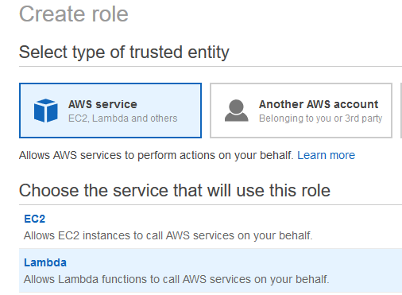

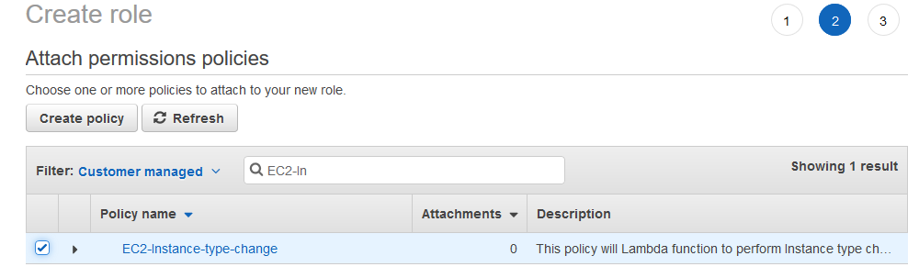

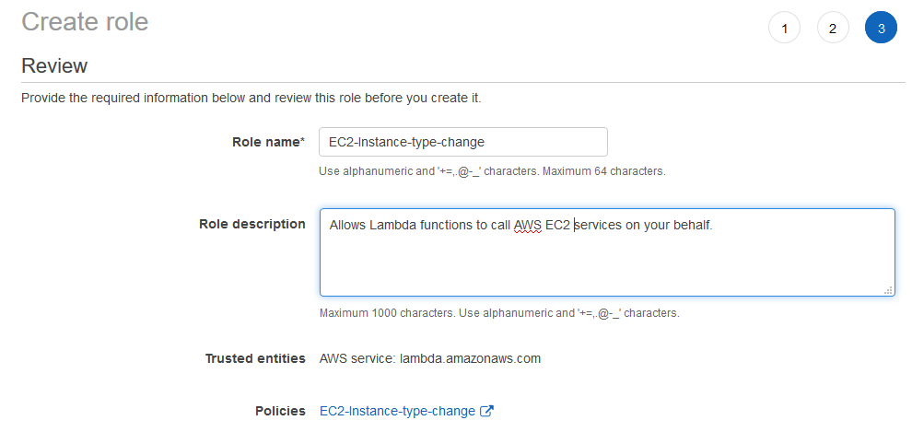 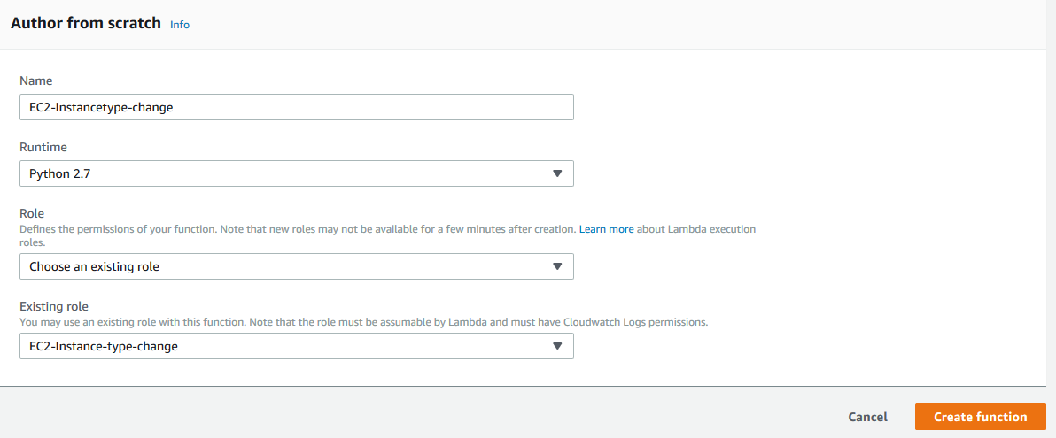

Click “Create function” wil create a Lambda function.

Copy and paste the python script in the lambda function code area. Make sure the Instance-Id is specified.

